JSPM’s, BHIVARABAI SAWANT INSTITUTE OF TECHNOLOGY RESEARCH, Wagholi, Pune
DVV Clarification for NAAC Criteria 2.3.2
1. | List of faculties using ICT facilities.
Sr. No | First Name | Surname | Branch
1 | PALLAVI | GULAVE | COMP
2 | VARSHA | VETAL
3 | YOGESH | PATIL
4 | ANJALI | ALMARE
5 | BALASAHEB | VYAVHARE
6 | TEJASHREE | SHINDE
7 | VAISHALI | PATIL
8 | POOJA | BARAWAKAR
9 | AMRUTA | JAGTAP
10 | SONA LI | PATIL
11 | BHARAT | BURGHATE
12 | VINAYAK | PATIL
13 | PRASHANT | JAWALKAR
14 | NITIN | SHIVALE
15 | GAURI | VIRKAR
16 | SUPRIYA | SHINDE
17 | SWATI | KHODKE
18 | MONALI | MOHITE
19 | MILIND | HEGADE
20 | AVINASH | JAGTAP
21 | JYOTI | DESHMUKH
22 | ADITI | CHATURVEDI
23 | PRAGATI | DEOLE
24 | SHWETALI | ERANDOLE
25 | VIJAY | SONAWANE
26 | SHRIKANT | MARKAD
27 | SHRISKAIL | PATIL
28 | AMOL | PATIL
29 | AMOL | RINDHE
30 | RAHUL | DESAI
31 | SHARAD | ADSURE
32 | SARITA | POL
33 | DEEPIKA | SHEWATKAR
34 | SHRIKANT | WAGHULE
35 | GAYATRI | BHANDARI
36 | ARCHANA | LOMTE
37 | ANUJ A | AROTE
38 | SWATI | GODSE
39 | AMOL | BAVISKAR
40 | SHEETAL | MANE
41 | PRAFULLA | SHARMA
42 | RINKU | BADGUJAR
43 | MEGHA | JADHAV
44 | FARH A | SHAIKH
45 | VRUNDA | BHUSARI
46 | RADHA | SHIRBHATE
47 | SANCHIKA | BAJPAI
48 | SHWETA | SHANWAD
49 | DIPALI | SURYAWANSHI
50 | SNEHAL | THOKALE
51 | SNEHAL | PATIL
52 | VIJAY | SAWANT | E&TC
53 | YOGESH | ANGAL
54 | PRAJAKTA | KATKAR
55 | SHWETA | PATIL
56 | PRIYA | SHIMPI
57 | SWETA | GANDHI
58 | DIPALI | BADGUJAR
59 | TRUPTI | CHAVAN
60 | VISHAL | PURANIK
61 | HARSHA | BHAMRE
62 | SHEETAL | DUBAL
63 | HARSHAL | WARKAR
64 | NAGARAJ | TIMALAPUR
65 | DNYANESHWAR | KHAIRNAR
66 | SUREKHA | DEOKAR
67 | SONALI | KSHIRSAGAR
68 | ASHWINI | PATIL
69 | VARSHA | SHINDE
70 | SUPRIYA | KHALATE
71 | PRIYANKA | RAMTEKE
72 | TUSH AR | KAFARE
73 | SANTOSHI | GUPTA
74 | MANSI | DEORE
75 | PRADNYA | MASKE
76 | SARIKA | BAGAL
77 | JANVI | TIMALAPUR
78 | ANIL | WANARE
79 | ANITA | GADE
80 | MAHADEO | NIKHILA
81 | SAYALI | RAWAT
82 | ROHINI | KHALKAR
83 | SURESH | DHAIGUDE
84 | SONALI | PARCHURE
85 | PRANEET | SHAH
86 | PRAJAKTA | PATIL
87 | MEENAKSHI | ANNAMALAI
88 | RUPA LI | RAKIBE
89 | MEGHA | GADEKAR
90 | ARCHANA | SAKHARE
91 | DILIP | BHOSALE
92 | VAISHNAVI | MASUR | ELECT
93 | SHITAL | GUDADHE
94 | PRIYANKA | DUSHING
95 | DEEPIKA | SRIVASTAVA
96 | SWARADA | MULEY
97 | MRITYUNJAYA | PATTED
98 | ANUPMA | KAMBHOJ
99 | RANJ ITKUMAR | BIRADAR
100 | NEHA | GANARAJ
101 | SAHEBRAO | PATIL
102 | CHHAYA | GAREWAL
103 | PANCHSHILA | PILLEWAR
104 | MANJUSHA | PATIL
105 | MANJUSHA | MISHRA
106 | PALLAVI | KADAM
107 | RAM RATAN | DEGALE
108 | TRUPTI | SAXENA
109 | AMRUTA | KAPSE
110 | POOJ A | SHINDE
111 | NIDHI | MISHRA
112 | MADHURI | NAMJOSHI
113 | NILA M | GHUGE
114 | ANUBHA | PANCHAL
115 | ANKITA | TIDKE | IT
116 | DEEPALI | SHINKAR
117 | MANJIRI | KOKATE
118 | MAHENDRA | KUMBHAR
119 | NILESH | THORAT
120 | PRAMOD | DHAMDHERE
121 | PALLAVI | SHEJWAL
122 | PARESH | SONAWANE
123 | NIDHI | SHARMA
124 | RUPA LI | MAHAJAN
125 | APPASAHEB | SALUNKHE
126 | PRIYADARSHAN I | BANDGAR
127 | SWITI | GAIKWAD
128 | AMIT | NICHKAT | MECH
129 | RAJKUMAR | RATHOD
130 | SAGAR | AWATE
131 | ZEN | ATHAWALE
132 | MURLIDHAR | VAIDYA
133 | AJIT | DORWAT
134 | SACHIN | NEHE
135 | OMKAR | SIRAS
136 | GANESH | GADE
137 | AMAR | KALE
138 | RAMESH | RUDRAPATI
139 | ASHWIN | DEOGADE
140 | VRUSHALI | DHANGE
141 | ARUN | PATIL
142 | BASAVRAJ | TAWADE
143 | SAGAR | DHOKALE
144 | GANESH | GHODAKE
145 | BALA JI | PATIL
146 | ADIK | YADAV
147 | SHWETA | DAREKAR
148 | VAISHALI | KHARADE
149 | SUNIL | CHANDWANI
150 | VIVE K | MOHITE
151 | PANKAJ | SHITOLE
152 | VENKATESH | DANGE
153 | PRABHULING | JATTI

2 | Photographs of ICT facilities available in Institute.
Computer Engineering Department class room 1
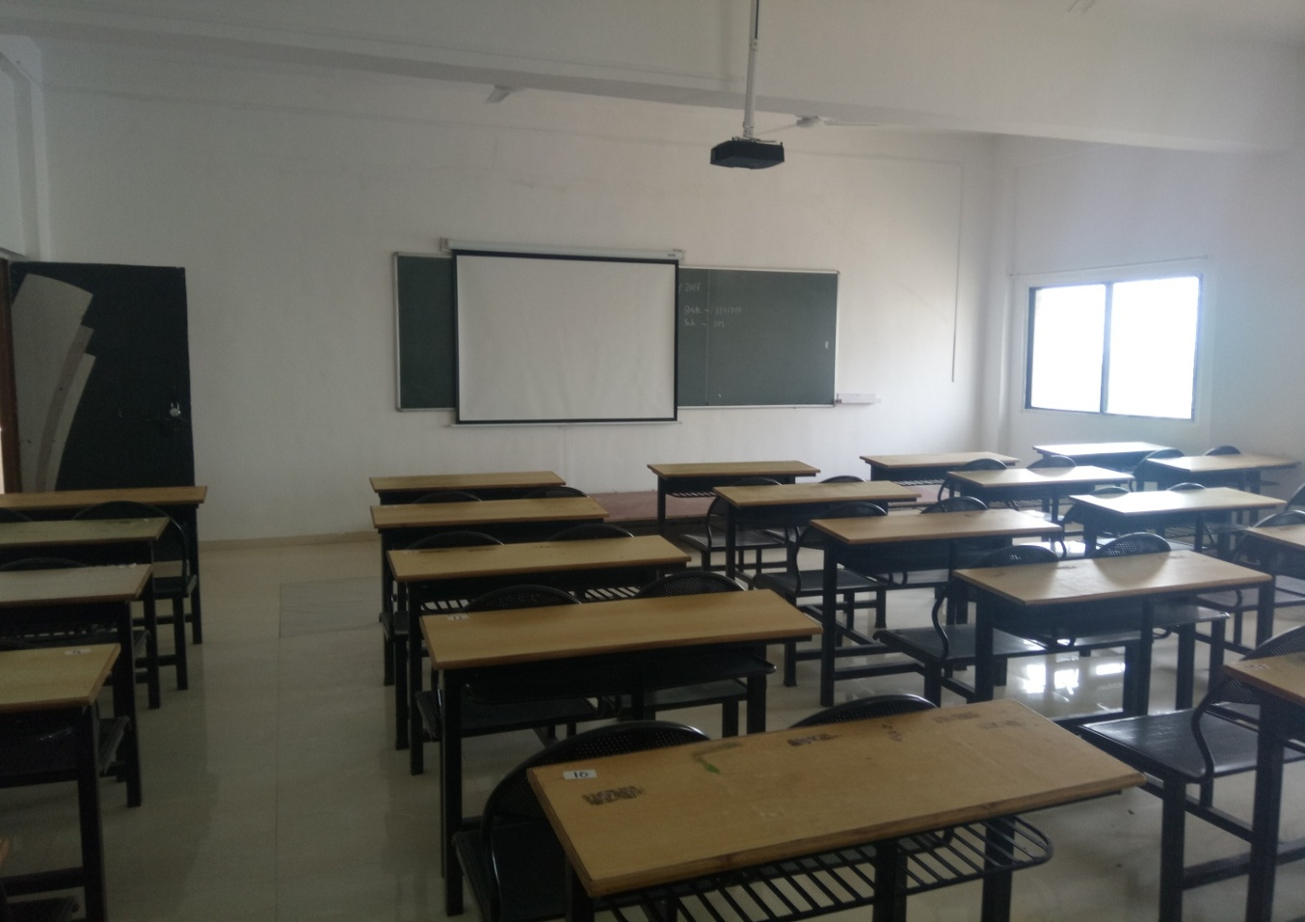
Comp class room 2
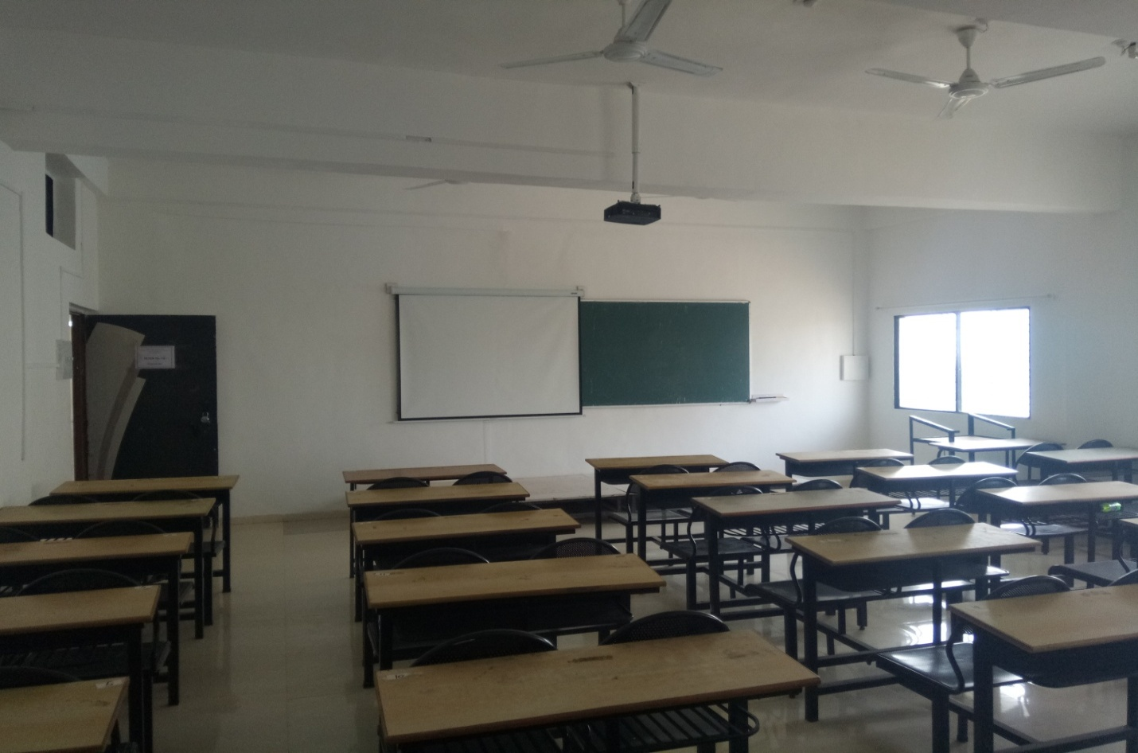

Comp class room 3
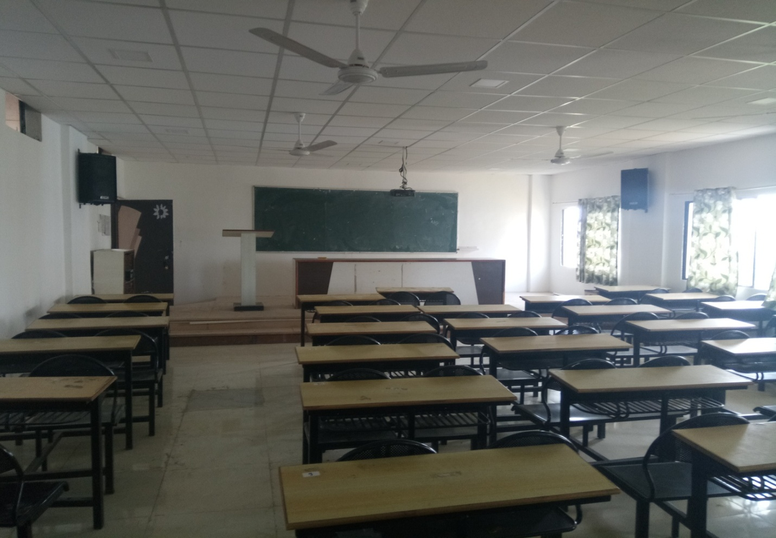
Electrical Class Room 1
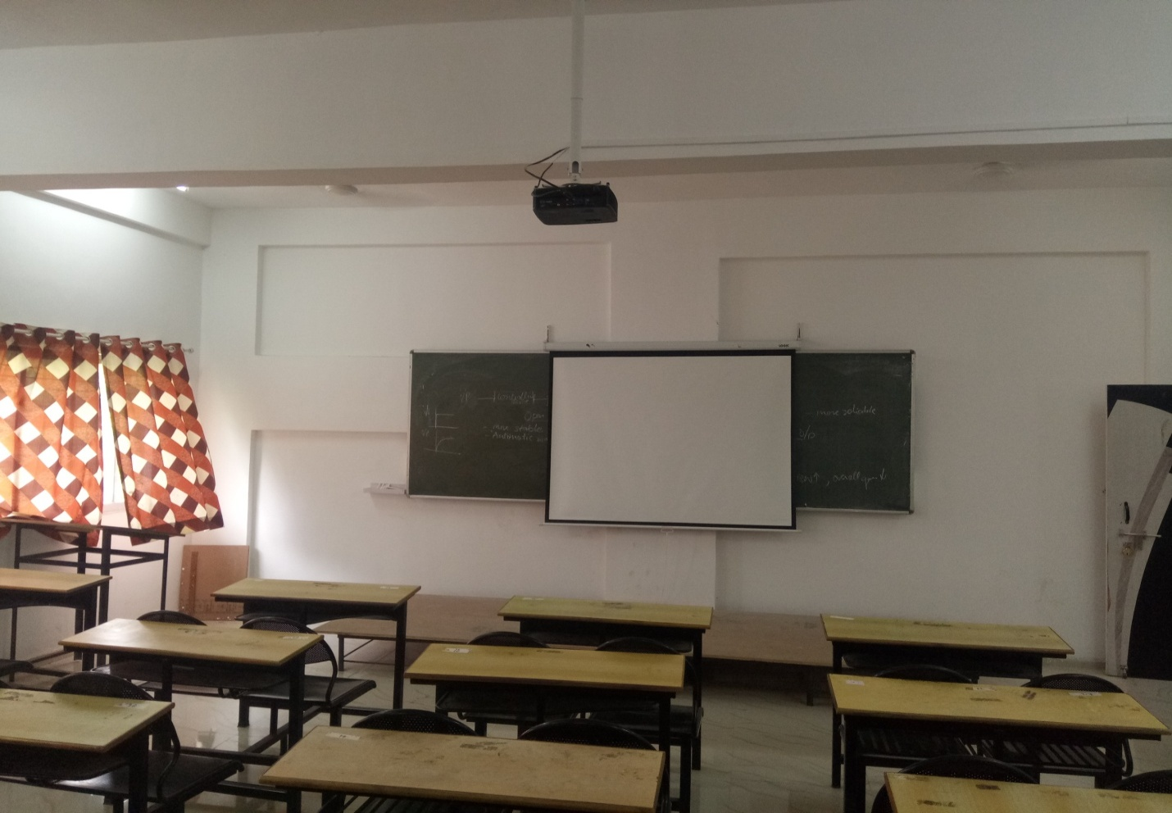
Electrical Class Room 2
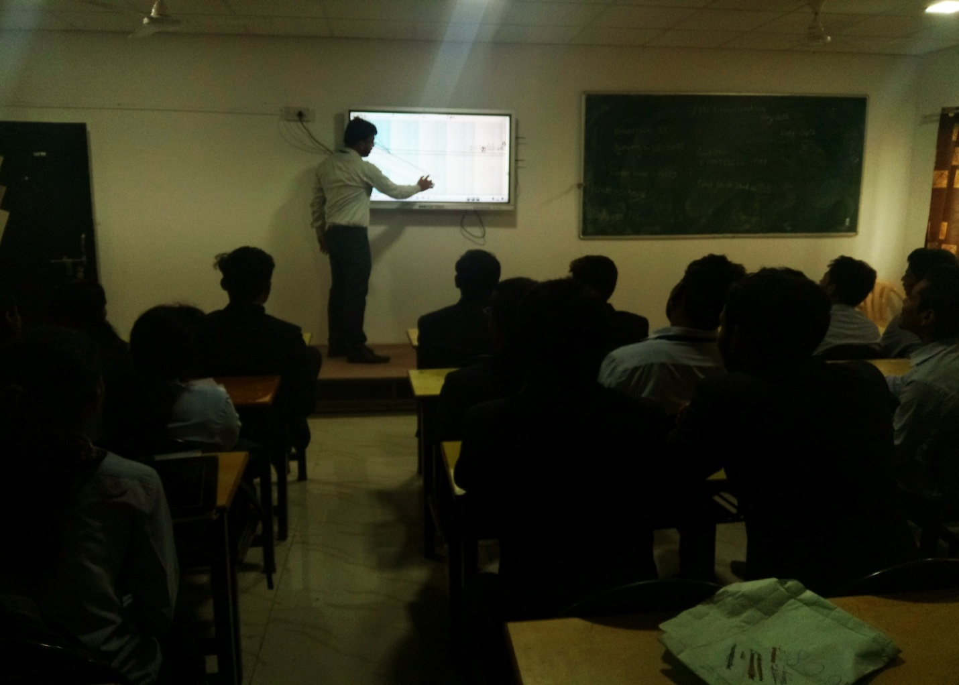
Electrical Class Room 3
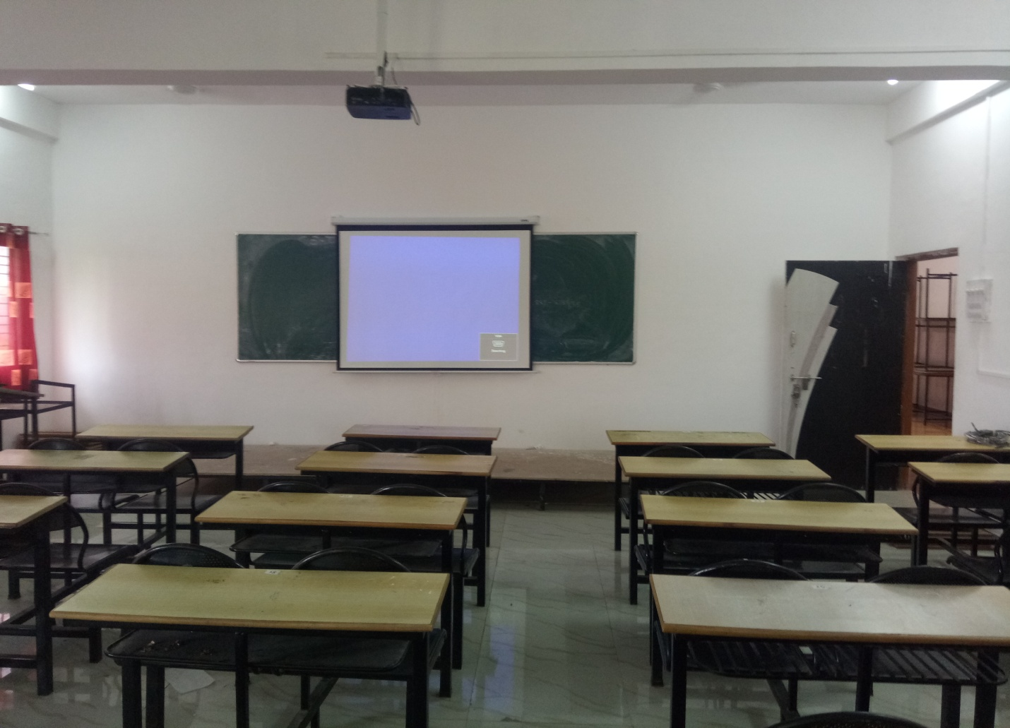

Electrical Class Room 4
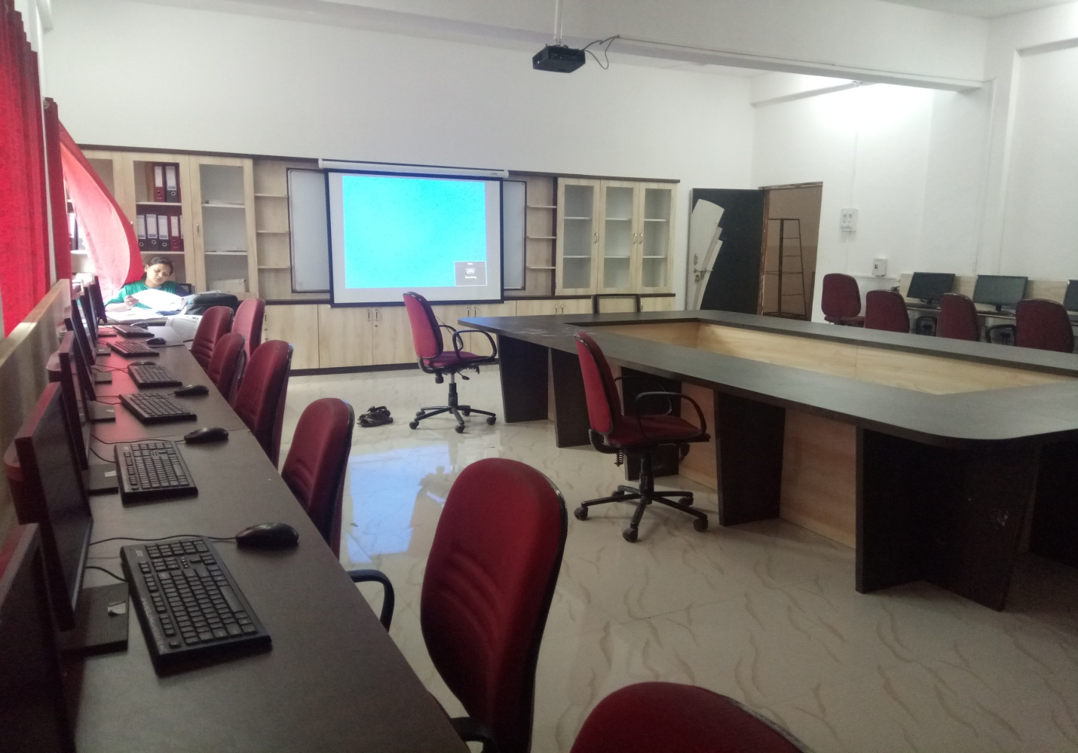
IT Class Room 1
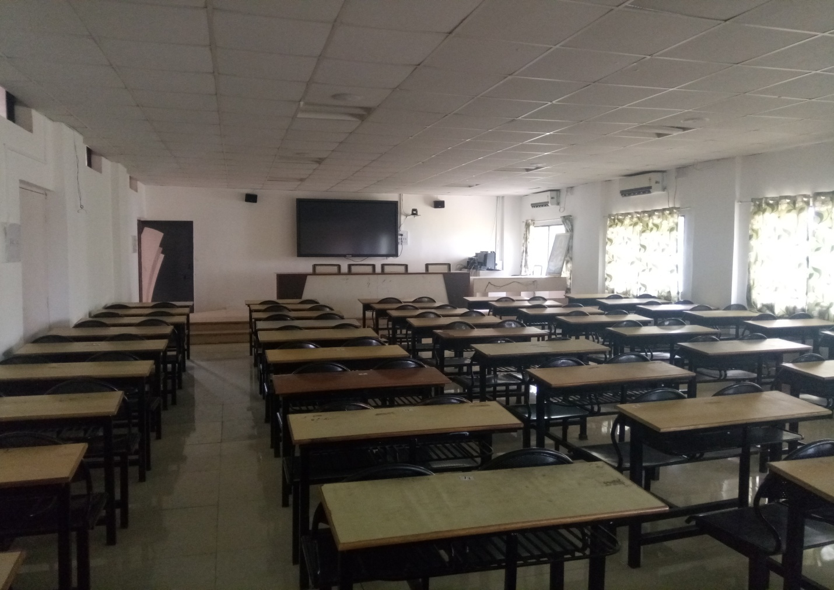

IT Class Room 2
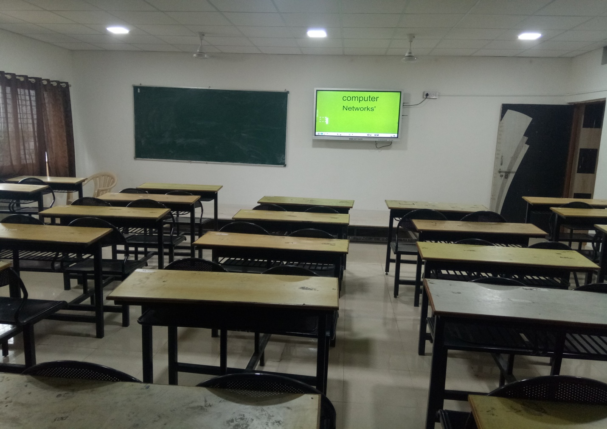
Mechanical Class Room 1
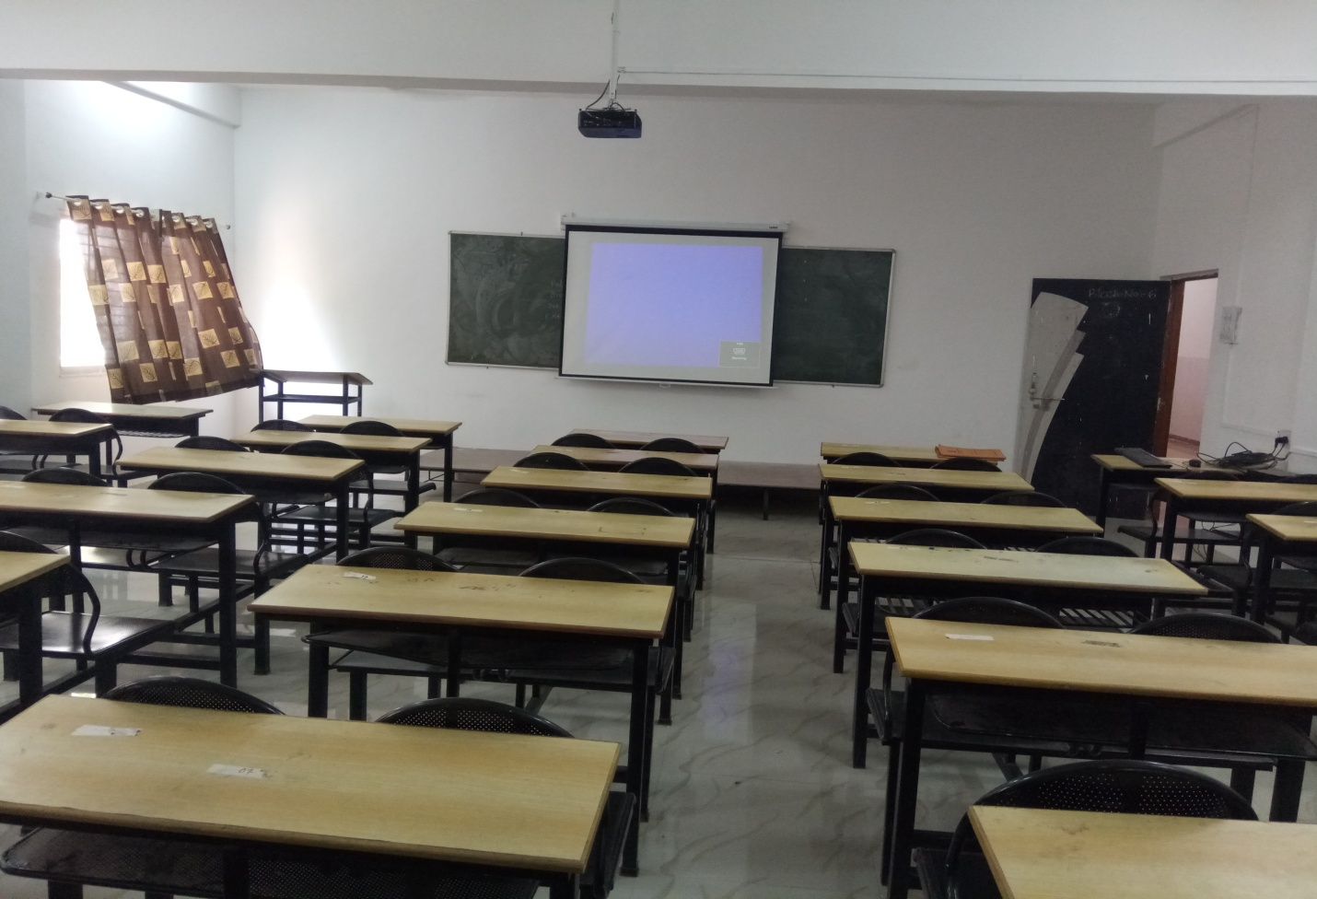

Mechanical Class Room 2
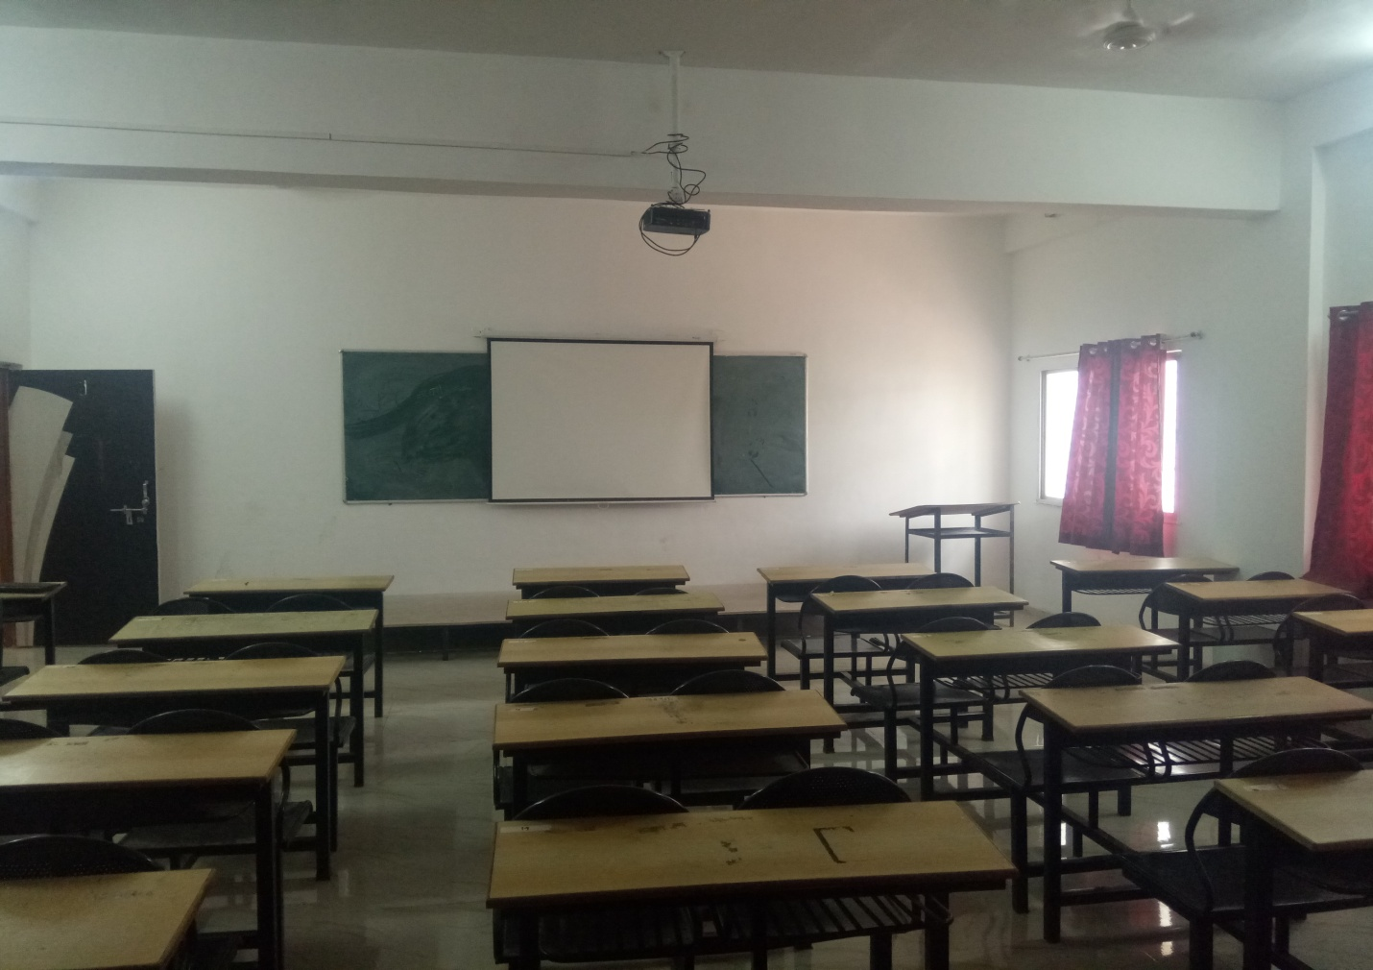
Mechanical Class Room 3
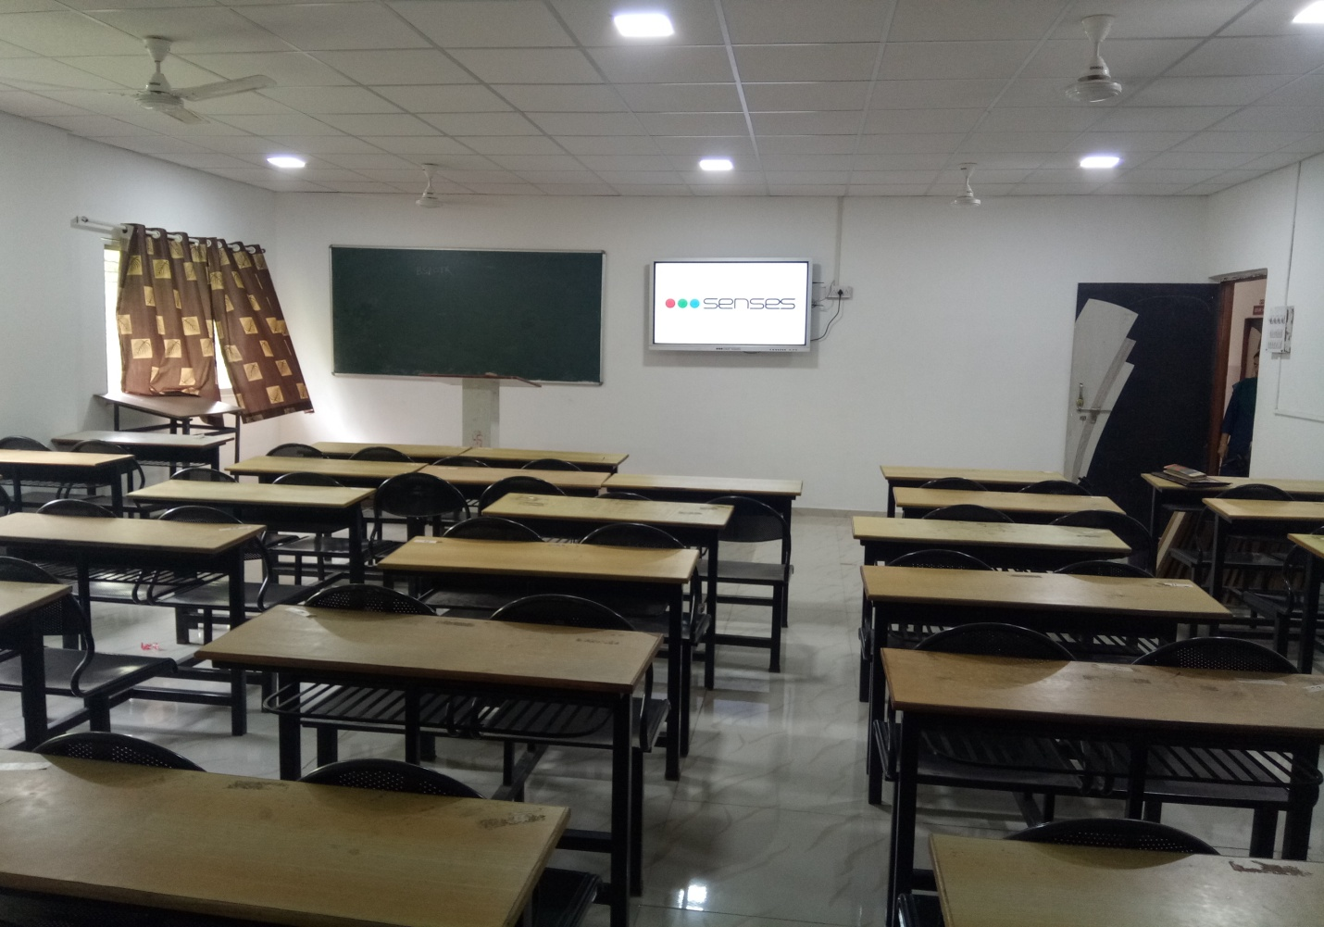

First Year Class Room 1
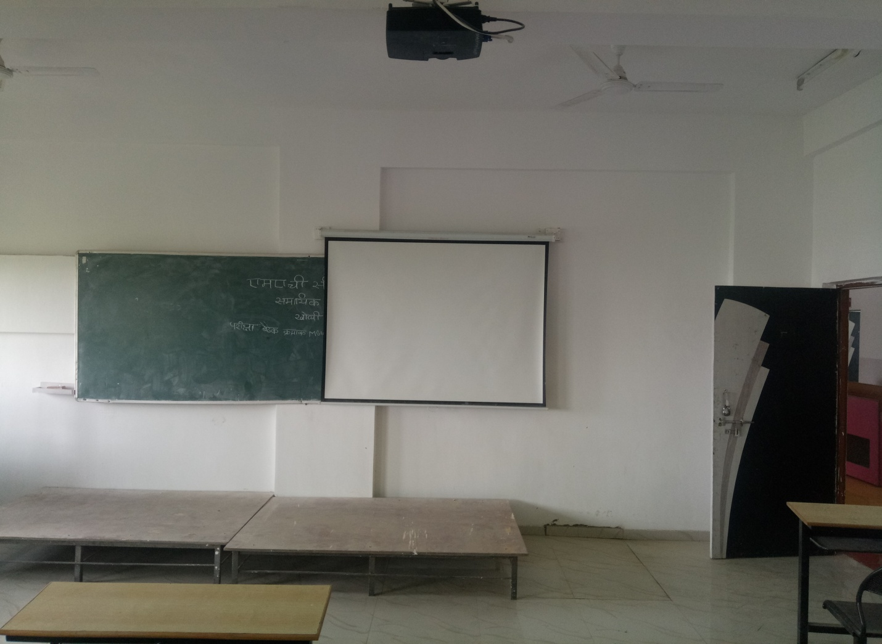
First Year Class Room 2

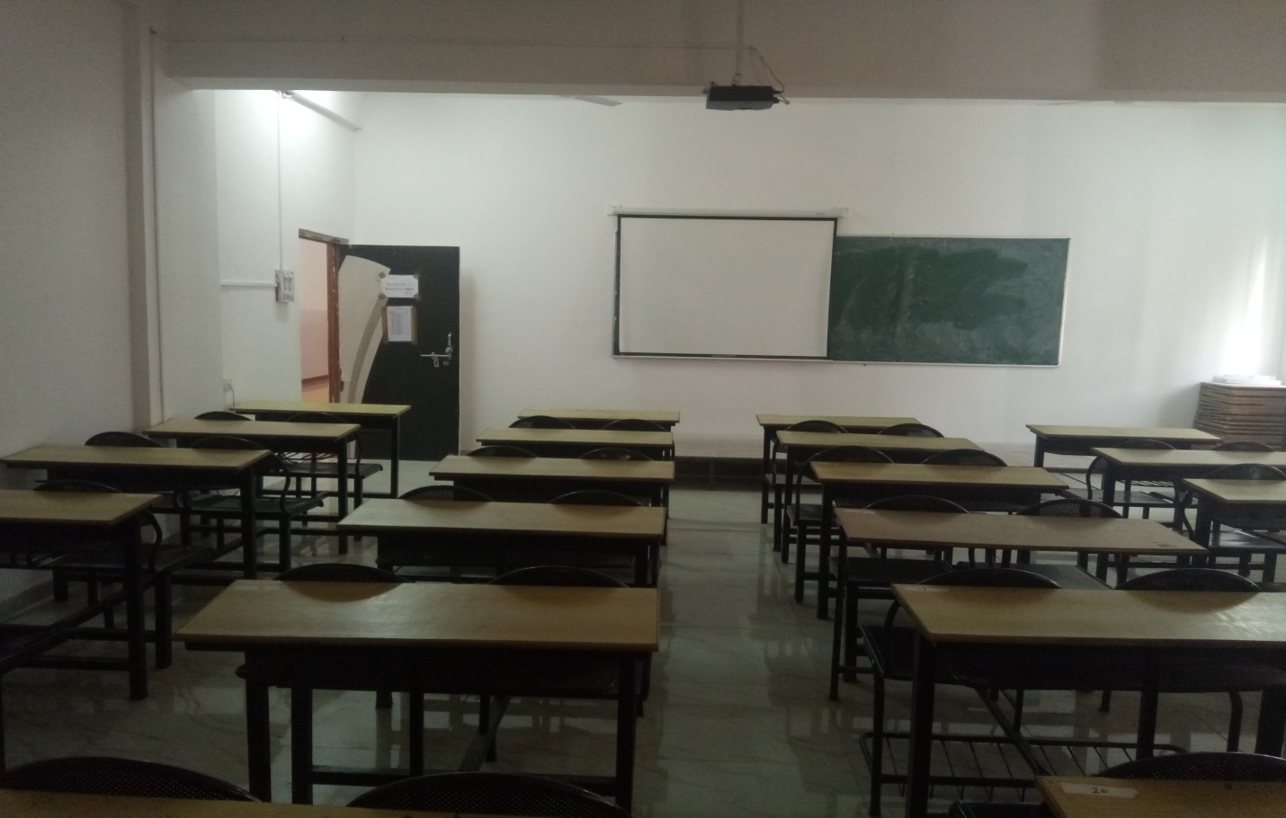

3. | Working link of ICT resources.

- Moodle Link
  - http://114.143.162.61/bsiotr/

